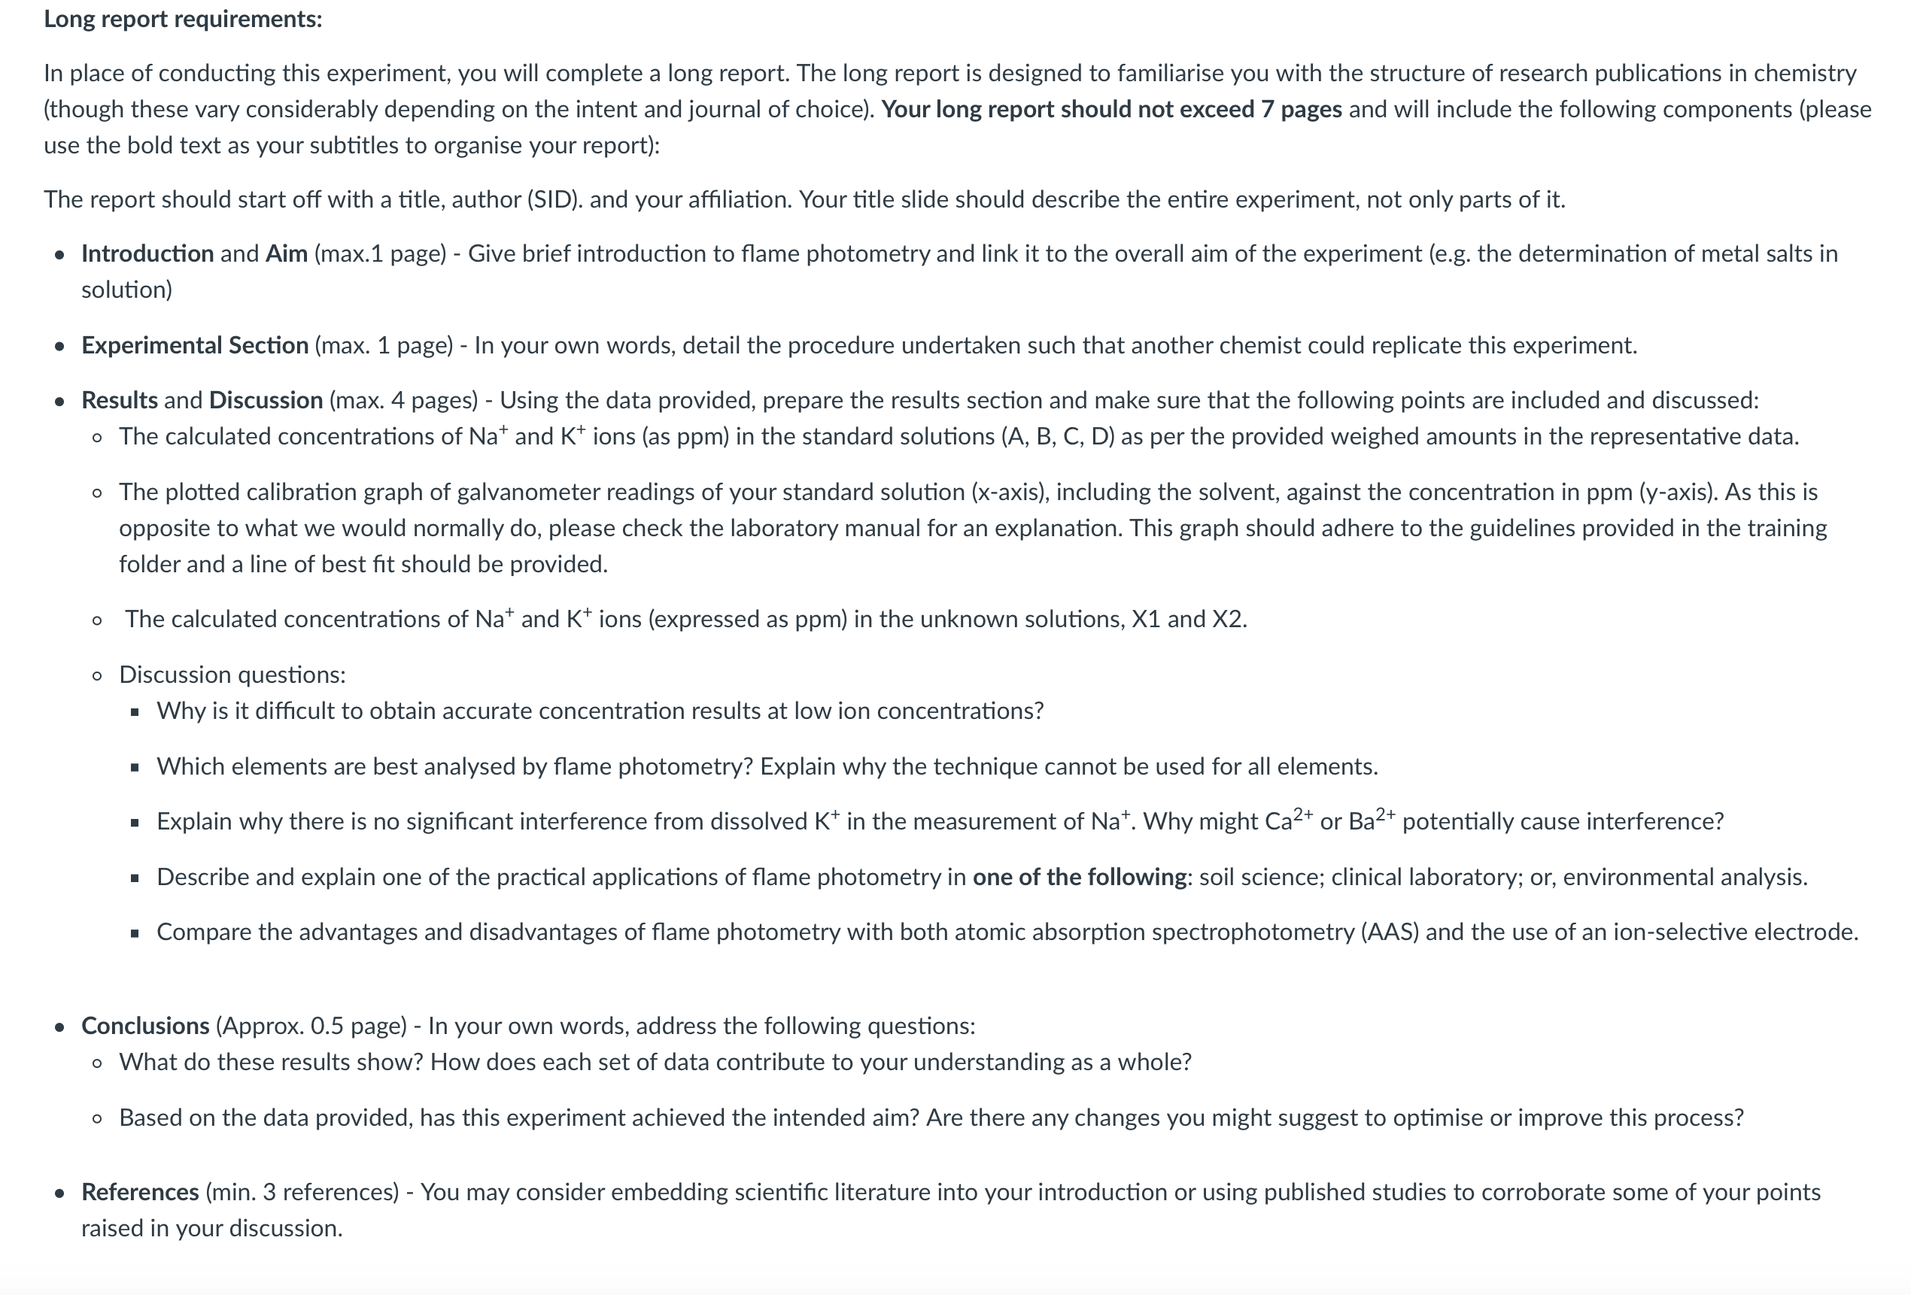

sheet for Experiment 2
Unknown Sample Number: | 990

NaCl and KCl must be weighed by difference to ±0.0001g on an analytical balance.
 | NaCl | KCl
Mass of weighing boat + reagent | 0.7318 | 0.9101
Mass of weighing boat | 0.4141 | 0.4135
Difference = Mass of reagent

Flame photometer readings for sodium
Solution | Galvanometer Readings |  |  | Mean Reading | Conc. Na⁺ (ppm)
Blank (distilled water) | 2 | 3 | 1 | ±
Standard Solution A | 14 | 14 | 14 | ± | ±
Standard Solution B | 27 | 26 | 27 | ± | ±
Standard Solution C | 51 | 51 | 51 | ± | ±
Standard Solution D | 63 | 69 | 66 | ± | ±
Unknown Solution X1 | 22 | 23 | 23 | ±
Unknown Solution X2 | 42 | 44 | 44 | ±

Flame photometer readings for potassium
Solution | Galvanometer Readings |  |  | Mean Reading | Conc. K⁺ (ppm)
Blank (distilled water) | 0 | 1 | 0 | ±
Standard Solution A | 26 | 26 | 25 | ± | ±
Standard Solution B | 54 | 54 | 54 | ± | ±
Standard Solution C | 101 | 101 | 104 | ± | ±
Standard Solution D | 125 | 129 | 133 | ± | ±
Unknown Solution X1 | 41 | 42 | 40 | ±
Unknown Solution X2 | 81 | 81 | 81 | ±

Na⁺, K⁺ conc. (ppm) in diluted unknown  (from graphs) | Na⁺ K⁺  X1 ± ±  X2 ± ±
ANSWERS  Na⁺, K⁺ conc. (ppm) in original unknown | Na⁺ K⁺  X ± ±

Determination of sodium and potassium by flame photometry
This is a one-week experiment, but you must prepare for the lab by bringing in suitable test samples, and you will present your results in an oral presentation the following week.
Flame emission spectrometry, also called flame photometry, is a useful method for the determination of metal salts in solution. Excited metal atoms, produced by spraying the solution into a flame, emit light of characteristic wavelengths. The intensity of a suitable spectral line is measured and compared with the intensities obtained by treating standard solutions of the metal in the same manner.
In this experiment, flame photometry is used to determine the concentrations of sodium and potassium in an issued unknown solution, as well as some samples of your choosing. More information about flame photometry can be found in Appendix 3 in this manual.
1. LEARNING OUTCOMES
After undertaking this experiment, you will have the following laboratory skills:
- Volumetric techniques (accurate dilutions of standards and unknowns)
- Use of a flame photometer
After undertaking this experiment and presenting your findings, you will understand:
- Calibration curves
- Analytical techniques for multiple dissolved elements Preparation of PowerPoint slides
- Oral presentation of scientific results
CHEMICALS USED AND SAFETY DATA
SELECTION OF SAMPLES TO STUDY
Sodium chloride Potassium chloride
Not hazardous
During this experiment, you have the opportunity to design a research question involving sodium and/or potassium concentrations, and use flame photometry to investigate it. In the previous lab session, you will need to find a partner and discuss the question that you want to investigate, and then come to the lab session prepared for this investigation. You should think of a research question that investigates how sodium and/or potassium levels differ in different samples. You will need to collect a sample bottle or bottles from the Service Room so that you can bring your samples (clearly labelled) with you to the lab session. You should aim for systems in which sodium and potassium levels are at least 2 ppm (if concentrations are too high, you will be able to dilute the samples). Your demonstrator will be able to assist you by giving you some examples of research questions that you could investigate.

3. PROCEDURE
This experiment, and the subsequent analysis and presentation, will be carried out in pairs.
Preliminary calculation
You require a primary standard solution containing 125 parts per million (ppm) of Na+ ions and 250 ppm of K+ ions.
Note: 1 ppm = 1 μg mL–1 = 1 mg L–1
In your online prework, you are asked to calculate the masses of NaCl and KCl which must be
dissolved in one litre of water to provide these concentrations of Na+ and K+ ions.
Preparation of solutions
Using distilled water prepare 1000.0 mL, in a volumetric flask, of a primary standard solution containing accurately known concentrations of about 125 ppm Na+ and 250 ppm K+ ions. Weigh the NaCl and KCl by difference (to 4 decimal places) on an analytical balance. Pipette 5.00, 10.00, 20.00 and 25.00 mL aliquots of this solution into four 500.0 mL volumetric flasks (labelled A, B, C and D) and adjust to volume with distilled water.
Obtain from the Service Room a solution containing unknown amounts of sodium and potassium chlorides. Transfer the solution quantitatively to a 500.0 mL volumetric flask and adjust to volume. Label this solution X.
Pipette 10.00 and 20.00 mL aliquots of solution X into two 100.0 mL volumetric flasks (labelled X1 and X2) and adjust to volume with distilled water.
You should also prepare aliquots of solutions for your own investigation. If required, you may need to dilute these solutions while you are running them.
More information about volumetric techniques, including pipetting, can be found in Appendix 2 in this manual.
Measurement of emission intensity
Take a sample tube rack for flame photometry, containing at least 7 test tubes. After thorough rinsing with distilled water and then the sample solutions, fill four sample tubes (labelled clearly with a felt pen A, B, C and D) with the four standard solutions, another 2 sample tubes (labelled X1 and X2) with the two unknown solutions, and tubes with solutions for your own investigation. Fill another tube with distilled water (blank).
Consult a demonstrator about the use of the flame photometer.
Waste Disposal:
• After you have measured your samples, dispose of your solutions down the sink and wash your glassware with deionised water. Test tubes should be disposed of in the glass bins. Glass pipettes can be left soaking in the pipette buckets at the end of the bench.
4. CALCULATIONS
From the amounts of NaCl and KCl that you actually weighed, calculate the concentrations of Na+ and K+ ions (as ppm) in the standard solutions (A, B, C and D). Plot a calibration graph of galvanometer readings (x-axis) of your standard solutions, including the solvent, against the concentration in ppm (y-axis). Although this is the reverse of common practice for data presentation, it is mathematically much more convenient because it allows an equation to be fitted from which you can directly calculate concentration in an unknown solution from the galvanometer reading. Fit the calibration data to a polynomial. You can vary the order of the polynomial, e.g. 1 = linear, 2 = quadratic, etc. to get the best fit to the experimental data.
From these equations and the mean readings of solutions X1 and X2 (corrected for the blank), calculate the concentrations of Na+ and K+ ions (expressed as ppm) in X1 and X2.
From the four results, calculate the mean concentrations of Na+ and K+ ions (in ppm) in your originally assigned unknown solution X.
You should then calculate Na+ and/or K+ levels in your own research samples.

